**Hong Kong Institute of Vocational Education**

**Department of Information and Communications Technology**

**ITP4501**

**Android Intent and Menus**

**Q3 Options Menu**

* Right click on res/drawable and then New, Vector Asset. Click the button next to "Clip Art:" to choose a image.

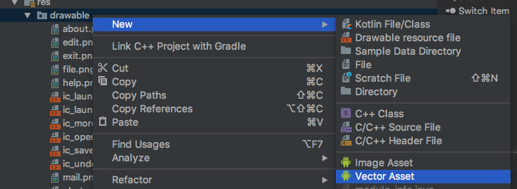 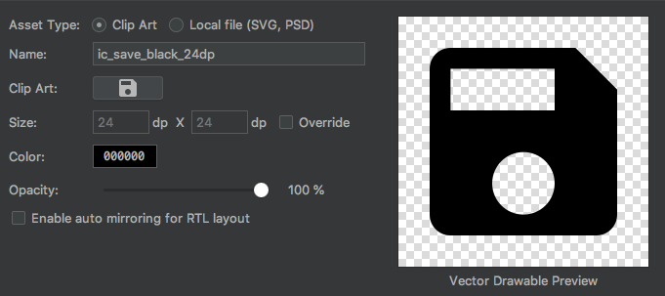

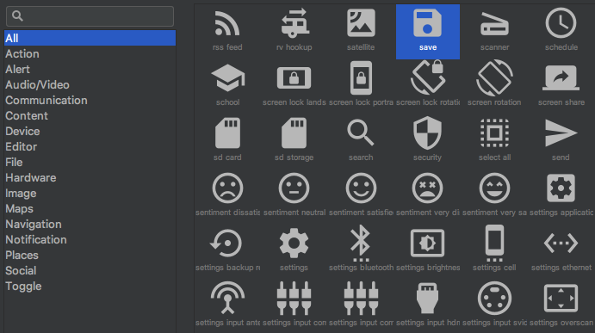

* Create an Android application *Lab05Ex3* to build two image buttons and an Options Menu as shown in Figure 3a.

|  |  |  |
| --- | --- | --- |
| Figure 3a | Figure 3b | Figure 3c |

* Clicking the “File” menu will display a sub-menu (Figure 3b).
* A dialog will display when selecting the option “About”. (Figure 3c)

Hint:

public void openDialog() {  
 AlertDialog.Builder builder = new AlertDialog.Builder(this);  
 builder.setMessage("This is an Options Menu");  
 builder.setTitle("About");  
 builder.setPositiveButton("OK", new DialogInterface.OnClickListener() {  
 @Override  
 public void onClick(DialogInterface dialog, int which) {  
 }  
 }).show();

* Clicking the “Exit” button will leave the program. Hint: finish()
* Build 2 Context Menus which are registered to the icons “Image” and “Email” as shown in Figure 4a and 4d.

|  |  |
| --- | --- |
| Figure 4a | Figure 4b |
| * A long pressing of the icon “**Image**” will create a context menu (Figure 4a). * A long pressing of the icon “**Email**” will create another context menu (Figure 4b)   Hint:  Remember to import android.view.ContextMenu .  Use view.getId() to find which view to call onCreateContextMenu. | |